03.04
MODIFICATION CAMPAIGNS
Process Design & AMOS Configuration Document
Purpose
This Process Design document is provided to Key-Users to record their key decisions regarding the AMOS Process design and the required AMOS configuration.
It is updated throughout the Project Definition Phase and used as the baseline for the Final Acceptance prior to Go-Live
Revision
Author, Name | Date | Notes
Adriano Azzurretti | 01.06.2024 | First Version

Table of Contents
1. Process Overview & Objectives 3
2. Regulatory References 3
3. Definitions & Glossary 3
4. Process Tasks 4
5. Process Dependencies 4
6. Process Flow 5
7. Process Design Questions 7
8. Data (Source) Mapping 8
9. Other Software Used 8
10. AMOS Configuration 9
a. Basic Data 9
b. Parameters 9
c. Workflows 9
d. Scheduled Tasks 9
e. API’s & Interfaces 10
11. UAT Guidance 10
12. Annex – Additional Info 10

Process Overview & Objectives

Process General Description:
This process concerns the drawing up of detailed implementation plans of major modifications. In these cases, it is common practice to stagger the concerned maintenance events, with the aim to efficiently use the aircraft availability for maintenance and to foster a synergic material planning / procurement process.
Main Process Objective (Outputs & Outcomes):
The output of this Business Process is a detailed layovers plan for the implementation of a modification campaign matching the airworthiness/commercial constraints while limiting the impact on flight operations and procurement.
When an engineering document is object of a modification campaign there is a clear, real-time information available in AMOS on whether the concerned events are planned on, ahead or behind schedule – against a linear trend. This information can be used by the responsible planning dept. to fine tune the implementation plan or to carry out corrective actions as required.

Regulatory References

- EASA Part M - Subpart B M.A.201 Responsibilities
- EASA Part M - Subpart C M.A.301 Continuing airworthiness tasks
- EASA Part M - Subpart C M.A.303 Airworthiness Directives
- EASA Part CAMO - CAMO.A.315(b)(5) Continuing airworthiness management
- FAA Title 14 CFR § 121.363 Responsibility for Airworthiness
- FAA Title 14 CFR § 91.405 Maintenance Required
- FAA Title 14 CFR § 91.409 Inspections

Definitions & Glossary

Key-Words | Explanation
Work Package | An object representing a Maintenance Layover in AMOS, which can contain the maintenance events to be performed during the layover itself
Leading Event in a Work Package | The check, the engineering document or the task that requires the longer ground time and/or the more resources in a work package. In the maintenance plans generation and update, it is the pivotal event of the maintenance layover, around which the work package content is built adding out-of-phase events or minor maintenance checks.
Maintenance Item / Maintenance Event | A scheduled or unscheduled maintenance task to be performed on the aircraft
Check | A collection of tasks that can be planned as a single Maintenance Item

Process Tasks

Business Process Task / Actions / Activities:
- Assess the technical compatibility between a modification and Line and Base maintenance checks, highlighting possible extra-grounding as required in each case
- Define start date and end date of a modification campaign
- Plan the modification – prioritising maintenance layovers already existing for compatible checks, then scheduling ad-hoc layovers – in accordance with a suitable material procurement plan
- Monitor the modification campaign progress and carry out corrective actions in case of disruptions

Process Dependencies

Input
- AMOS Business Process 01.04 – AD and SB Assessment: The technical assessment of the Engineering Document that represents a modification is a prerequisite for its planning
Connected
- AMOS Business Process 03.01 – Planning: Within this business process, the layovers for the checks are created and managed in accordance with the relevant airworthiness and operations constraints, including the impacts of possible extra-grounding generated by the inclusion of modifications. Ad-hoc layovers concerning the various modification campaigns are also merged in the maintenance plans and managed within the Planning Business process.
- AMOS Business Process 03.03 – Reporting Back: The use of AMOS-to-AMOS transfer of Work Package and Work Package Results guarantees that the closure/deferral/not-perform status for each Maintenance Item is transferred into the Operator’s AMOS. Reporting Back is, however, a necessary process to be executed in the Operator’s AMOS at the release to service of the AC and before the closure of the Work Package.
- AMOS Business Processes in area 08 – Aircraft Maintenance are the natural clients of the Planning Processes – including the modifications campaigns planning – after the Release of the Work Package to the MRO. The performance of the assigned modification is a prerequisite for its reporting back, which closes the loop in the Modification Campaigns process.
- AMOS Business Process 03.03 – Reporting Back: The reporting back of the modification after the task has been performed updates the modification status of the aircraft and the modification campaign progress
Output
- AMOS Business Process 09.01 – Material Planning: The material planning and procurement departments rely on the planned dates of the modification maintenance events on each aircraft. This allows a timely procurement and/or segregation of the parts needed for the modification’s implementation and avoids unnecessary spikes, overstock and delays due to no parts available.

Process Flow

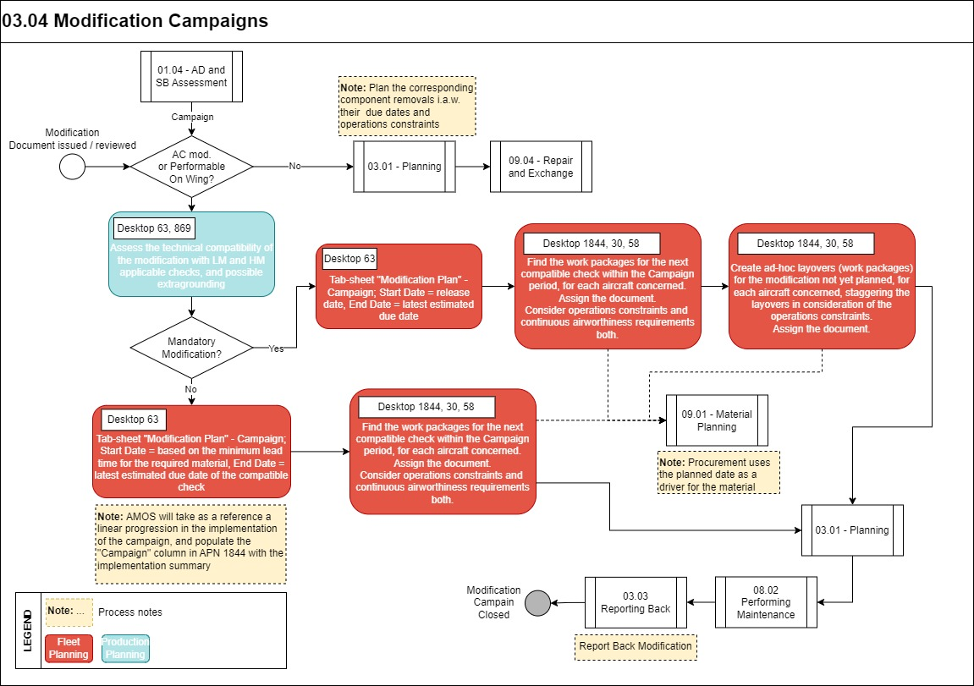
Process Flow Notes:
- The main driver in planning of non-mandatory modifications is minimising the impact on operations, as they are not subject to strict airworthiness requirements.
In case, based on the results of the financial assessment made beforehand on a non-mandatory major modification, there is a strong commitment to a date for the completion of the concerned modification campaign (e.g., due to commercial reasons, or financial bonuses offered for the completion of the modification campaign within a certain date, etc.), the modification should be processed in the same way as a mandatory one in the Modification Campaigns process.
- Components major modifications performable in the shops are managed within the normal planning process with the schedule of the concerned components removal. The implementation of the modification is then managed in the Repair and Exchange process.

Process Design Questions

# | Question | Answer
1 | Is there a dedicated team within the planning department in charge of major modification assessment and planning?
2 | In your organization, is the operator’s engineering department in charge of assessing the technical compatibility of SB/EO with letter checks, and potential extra-grounding to be considered? Is any internal MRO’s production engineering dept. either delegated or providing its support?
3 | Does the procurement play an active role in the major modifications planning / staggering, e.g., based on the lead time and the availability of the concerned parts and special tools?
4
5
6

Data (Source) Mapping

Data Sources | Description | Volume / Manual / Automatic / Static / Dynamic

Other Software Used

Other Software | Used by: | Description

AMOS Configuration

Basic Data

Basic Data Table | Notes
Classification Code | Each Document in View/Edit Modifications can be defined with different Classifications. View/Edit Modifications -> Markings tab-sheet ->Document Classifications. The classifications can be used for searching purposes in the document search area.
Document Type of Change | Type of Change: needed to define the type of change per document in View/Edit Modifications program "Main" tab-sheet (e.g., Minor Change, Major Change, etc.)

Parameters

Parameter Code | Parameter Name | Notes | Comments / Decisions
1771 | MF - Calculation of Mod. Campaign | Use this parameter if information related to Modification Campaigns should be calculated with the Maintenance Forecast.  If the String value is set to Y, then the information will be calculated. | String=Y

Workflows

Workflow Number | Workflow Name | Notes
168 | Document saved | This workflow is triggered when a document is saved

Scheduled Tasks

Scheduled Task Reference | Frequency | Notes
AircraftMaintenanceForecastService | Daily, or after the definition of an aircraft modification campaign in APN 63 | This scheduled task calculates the ToGo, Since Req and Expected Date of all events related to an Aircraft, including the relevant modification campaign info – if any
ComponentMaintenanceForecastService | Daily, or after the definition of a component modification campaign in APN 63 | This scheduled task calculates the ToGo, Since Req and Expected Date of all events related to components, including the relevant modification campaign info – if any

API’s & Interfaces

Reference | Direction | Trigger | Frequency
NIL

UAT Guidance

Annex – Additional Info

